AIR UNIVERSITY, KAMRA
Department of Computer Science

FULL STACK WEB DEVELOPMENT
Assignment 05
AccessDesk
Role-Based Customer Access Portal using Node.js, Express.js, MySQL and jQuery AJAX
Student Name | Wasif Ali
Registration ID | 245187
Class | BSCS-F-24-B
Course | Full Stack Web Development
Database / Table | mydb8 / customers4
Submission Deadline | 27 October 2026

Table of Contents
1. Overview 3
1.1 Technologies 3
2. Roles and Access Rules 3
3. Access-Check Flow 3
4. Setup and Running 4
4.1 Requirements 4
4.2 Start the Application 4
5. API Routes 5
6. Security Design 5
6.1 Role Rules Enforced on the Server 5
6.2 Field Projection and Parameterized SQL 6
6.3 Summary of Safeguards 6
7. User Interface 6
8. Verification 6
8.1 Required Cases 7
8.2 Additional Cases 7
9. Screenshots 7
Screenshot 1: Roles 7
Screenshot 2: Search 9
Screenshot 3: 403 Forbidden 10
Screenshot 4: 429 Too Many Requests 10
Additional Screenshots 11
10. Assessment Checklist 13
11. Conclusion 13

1. Overview
AccessDesk is a web portal in which one customer database is shared by users with different levels of access. The caller is identified only by an API key sent in the x-api-key request header. The Node.js server decides what the caller may view or request, applies a row limit and a credit allowance, and returns only the fields that the role is allowed to see. The browser page (HTML, CSS and jQuery AJAX) sends requests and displays the answers; it contains no database credentials and makes no permission decisions.

1.1 Technologies
Layer | Technology
Frontend | HTML, CSS and jQuery (AJAX with JSON); the table updates without a page refresh
Backend | Node.js with Express.js, the cors middleware and the mysql package
Database | MySQL on XAMPP: existing database mydb8, table customers4 (columns name and address)
Requests | GET requests, the API key in the x-api-key header, JSON responses

2. Roles and Access Rules
Four API-key profiles are defined in server.js. The Student and Teacher limits of the lecture are unchanged; Guest and Admin were added. Each role has its own demo key, row limit, credit allowance, permitted actions and visible fields.
Role | Demo API key | Max rows | Credits | Permitted actions | Visible fields
Guest | guest-key-000 | 2 | 4 | Load only | Name
Student | student-key-123 | 3 | 8 | Load + Search | Name, Address
Teacher | teacher-key-456 | 10 | 30 | Load + Search | Name, Address
Admin | admin-key-789 | 20 | 50 | Load + Search + Usage | Name, Address

One approved API request uses one credit. When a role has no credits left, the next request is rejected with HTTP 429. Rejected requests (401, 403 and 400) do not use a credit. Credits are kept in server memory, so restarting Node.js resets them, as allowed by the assignment.

3. Access-Check Flow
Every customer route runs the same middleware chain before any SQL is executed. The checks are made in a fixed order, and the first failed check ends the request with its own status code.
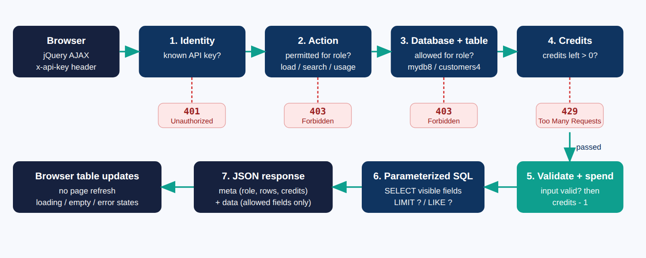
Figure 1: Order of access checks and request flow
- Identity (401). The key is looked up with Object.hasOwn(), so names such as __proto__ cannot match. An unknown or missing key returns 401 and no data.
- Permitted action (403). Each profile lists its allowedActions. A Guest calling Search, or a non-admin calling Usage, receives 403.
- Database and table (403). The profile must list mydb8 and customers4 in allowedDatabases and allowedTables.
- Credits (429). A role with zero credits is rejected before SQL runs.
- Validate and spend. The search text is validated first (400 if empty or too long). Only then is one credit deducted.
- Parameterized SQL. The row limit and the search pattern are bound values. The selected columns come from a fixed whitelist for the role.

4. Setup and Running

4.1 Requirements
- XAMPP with MySQL started. The existing database mydb8 with table customers4 (columns name and address) is used; no new SQL needs to be imported.
- If the table does not exist, import database/setup_optional.sql in phpMyAdmin. It creates the table and adds sample rows only when the table is empty.
- Node.js installed.

4.2 Start the Application
- Open the accessdesk folder in VS Code and open a terminal in that folder.
- Run npm install (first time only) and then node server.js. The terminal lists the four roles and prints "MySQL connected".
- Open http://localhost:3000 in the browser.
- Alternative: copy public/index.html and public/jquery.min.js to C:\xampp\htdocs\accessdesk\ and open http://localhost/accessdesk/index.html. CORS allows this.
Note. Restart Node.js before the verification sequence so that every role starts with its full credits. Open the page through http://localhost, not by double-clicking the HTML file, because a file:// page has no valid origin for CORS.

5. API Routes
Endpoint | Allowed roles | Behaviour
GET /api/customers?limit=10 | All four roles | Returns min(requestedRows, maxRows) records with only the role’s visible fields
GET /api/customers/search?name=Ali | Student, Teacher, Admin | Searches names with a bound LIKE value, limited to the role’s maxRows. Guest receives 403
GET /api/access/summary | Admin only | Returns total, used and remaining credits for each role. Never returns API keys or database credentials

Successful customer routes return data together with metadata. A Guest response contains the name field only; the address column is not selected from MySQL and is never sent to the browser.
Example response of GET /api/customers?limit=10 for a Student
{
"meta": {
"role": "student", "remainingCredits": 7,
"database": "mydb8", "table": "customers4",
"fields": ["name", "address"],
"requestedRows": 10, "allowedRows": 3, "returnedRows": 3
},
"data": [ { "name": "Ali Raza", "address": "Taxila" }, ... ]
}

6. Security Design

6.1 Role Rules Enforced on the Server
server.js: authorize() middleware
function authorize(action) {
return function (req, res, next) {
const key = req.get('x-api-key');
const user = key && Object.hasOwn(USERS, key) ? USERS[key] : null;
if (!user) return denied(res, 401, 'Unauthorized: invalid or missing API key');
if (!user.allowedActions.includes(action))
return denied(res, 403, 'Forbidden: ' + action + ' is not permitted ...', user);
if (!user.allowedDatabases.includes(DATABASE)) return denied(res, 403, ...);
if (!user.allowedTables.includes(TABLE)) return denied(res, 403, ...);
if (user.credits <= 0) return denied(res, 429, 'Too Many Requests ...', user);
req.currentUser = user;
next();
};
}

6.2 Field Projection and Parameterized SQL
server.js: role-specific columns and the bound search value
const COLUMNS = { name: 'name', address: 'address' }; // fixed whitelist
function selectSql(user) {
const cols = user.visibleFields.map(f => COLUMNS[f]);
return 'SELECT ' + cols.join(', ') + ' FROM ' + TABLE; // guest: SELECT name FROM customers4
}

app.get('/api/customers/search', authorize('search'), validateSearch, spendCredit, function (req, res) {
const pattern = '%' + escapeLike(req.searchName) + '%';
db.query(selectSql(user) + ' WHERE name LIKE ? LIMIT ?', [pattern, user.maxRows], ...);
});

6.3 Summary of Safeguards
- The Guest SQL statement selects only the name column, so the address never leaves the database for that role. Hiding it with CSS would not be secure.
- The row limit and the search pattern are passed as bound values; characters such as % and _ typed by the user are escaped so they are searched literally.
- MySQL credentials exist only in server.js. The browser page contains the demo keys and the API address only.
- The usage endpoint returns role names and credit counts only. API keys and database settings are never included.
- CORS accepts only localhost and 127.0.0.1 origins, allows the x-api-key header and answers the browser’s OPTIONS preflight. Other origins receive no CORS header and are blocked by the browser.
- If MySQL fails after a credit was deducted, the credit is refunded and a clear 500 message is returned.
- Unknown API endpoints return a JSON 404.

7. User Interface
The page follows the suggested layout: a role and API-key selector, a requested-rows field, a search field and three action buttons (Load Customers, Search Customers, View Usage). Three cards show the active role badge, the row allowance (for example "3 of 10 requested") and the credits left. The server answer is shown in a colour-coded status bar with the HTTP code, a loading indicator while a request is running, a results table that adapts to the fields returned, an empty-result message, and a request log of the latest calls. The Search and Usage buttons stay available for every role on purpose: the server, not the page, must be the one that refuses forbidden actions.

8. Verification
The cases below were executed against the running API after restarting Node.js. All of them produced the expected result.

8.1 Required Cases
No. | Test | Expected | Actual | Observed result
T1 | Unknown API key | 401 | 401 ✓ | No customer records returned
T2 | Guest loads 10 records | 200 | 200 ✓ | At most 2 names; no address field in the response
T3 | Guest attempts Search | 403 | 403 ✓ | Search is not permitted for the guest role
T4 | Student loads 10 records | 200 | 200 ✓ | At most 3 records
T5 | Teacher loads 10 records | 200 | 200 ✓ | At most 10 records
T6 | Student attempts a 9th request | 429 | 429 ✓ | No records returned; credits finished
T7 | Non-admin opens usage endpoint | 403 | 403 ✓ | Access denied

8.2 Additional Cases
Test | Status | Observed result
Admin opens usage endpoint | 200 ✓ | roles: guest 3/4, student 0/8, teacher 29/30, admin 49/50; keys in response: False
Admin loads 10 -> max 20 allowed | 200 ✓ | 10 rows (requested 10)
Admin requests 100 rows | 200 ✓ | 20 rows (capped at maxRows 20)
Teacher searches 'Ali' | 200 ✓ | 5 rows: Ali Raza, Alina Shah, Ali Hamza, Hina Malik, Shahzaib Ali
Search with empty name | 400 ✓ | Bad Request: enter a customer name to search
Search '%' is literal, not a wildcard | 200 ✓ | 0 rows
SQL injection attempt in search | 200 ✓ | 0 rows (treated as plain text)
Invalid limit 'abc' -> role maximum | 200 ✓ | 10 rows
Unknown endpoint | 404 ✓ | API endpoint not found

9. Screenshots

Screenshot 1: Roles
Each role loads with 10 rows requested (the Admin requests 20). The row allowance card shows the role maximum, and the Guest table contains the Name column only.
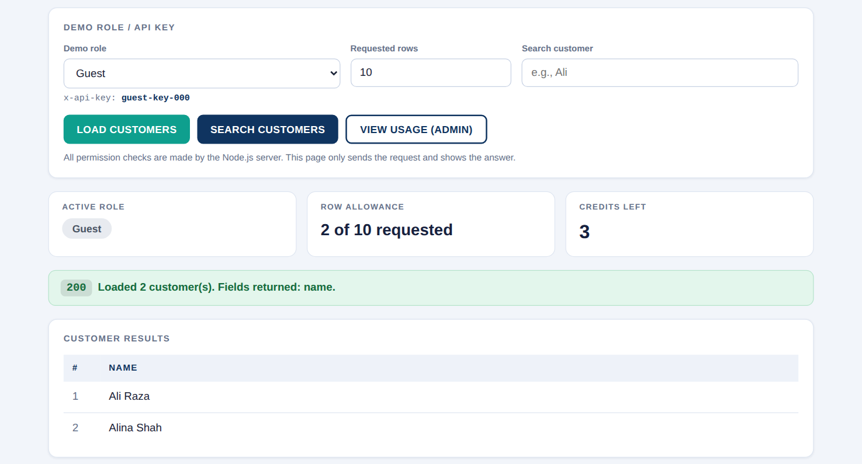
Figure 2: Guest: 2 of 10 rows, Name only, 3 credits left
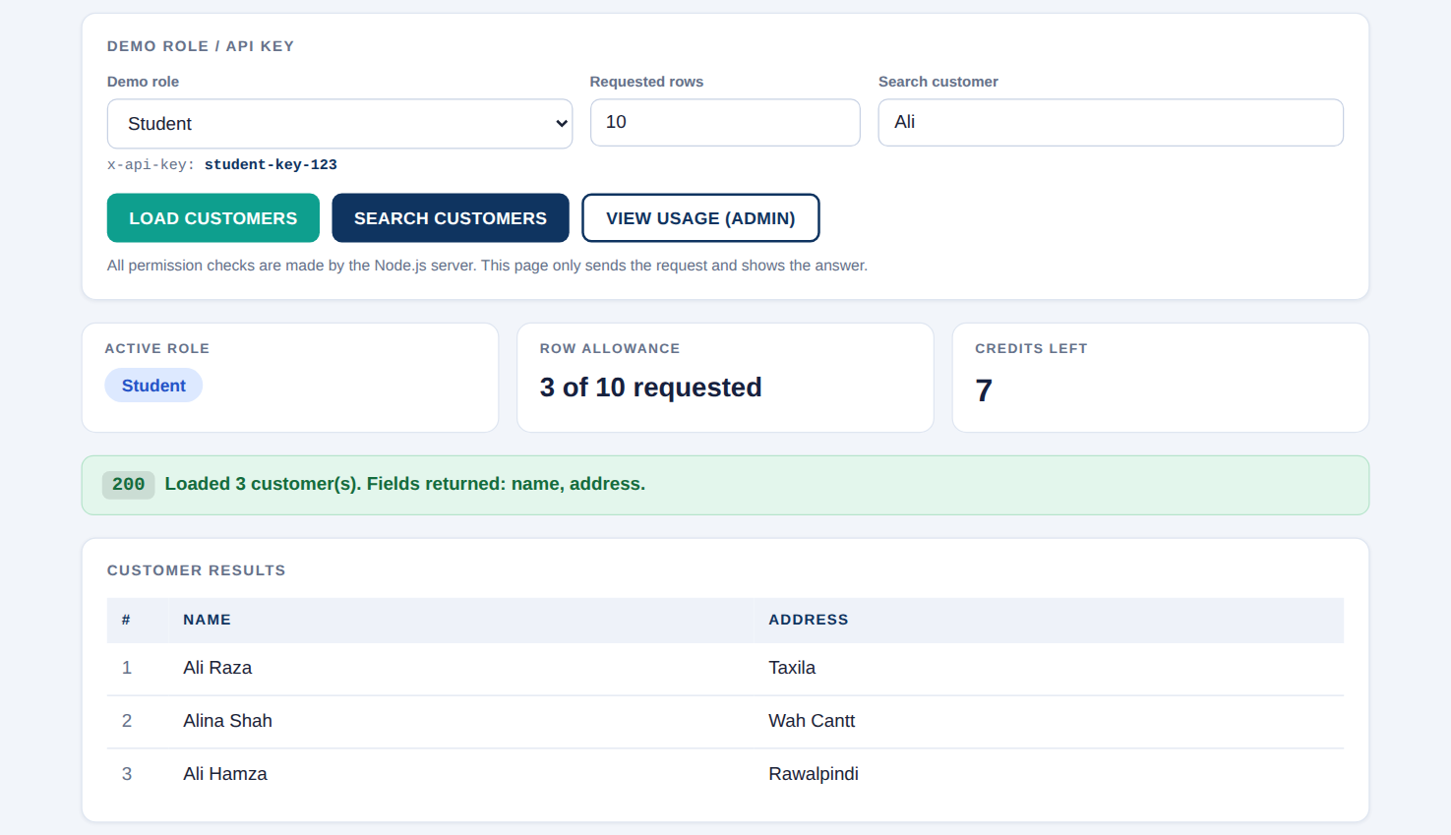
Figure 3: Student: 3 of 10 rows, Name and Address, 7 credits left
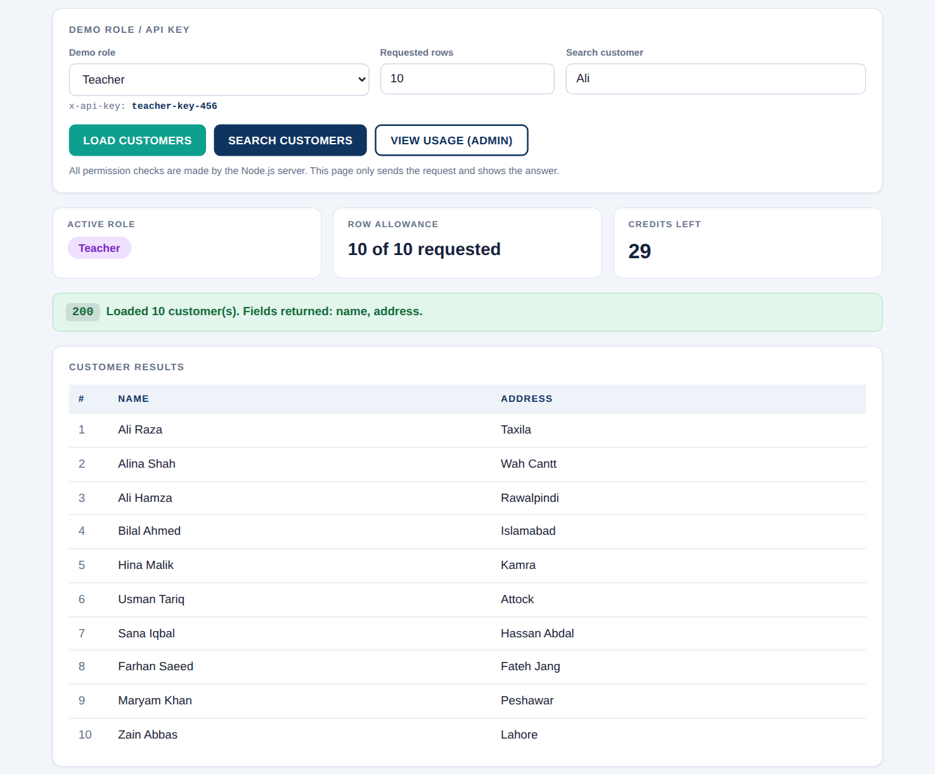
Figure 4: Teacher: 10 of 10 rows, 29 credits left
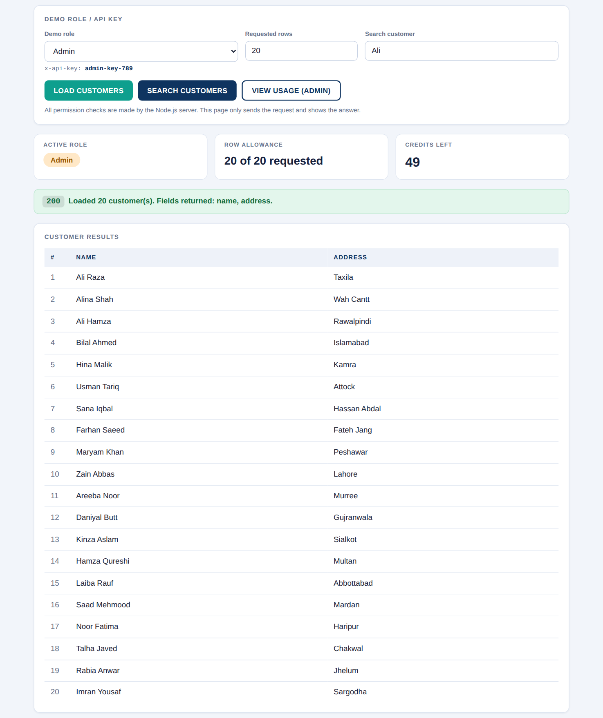
Figure 5: Admin: 20 rows allowed, 49 credits left

Screenshot 2: Search
A Student searches for "Ali". The result is limited to the Student maximum of 3 rows.
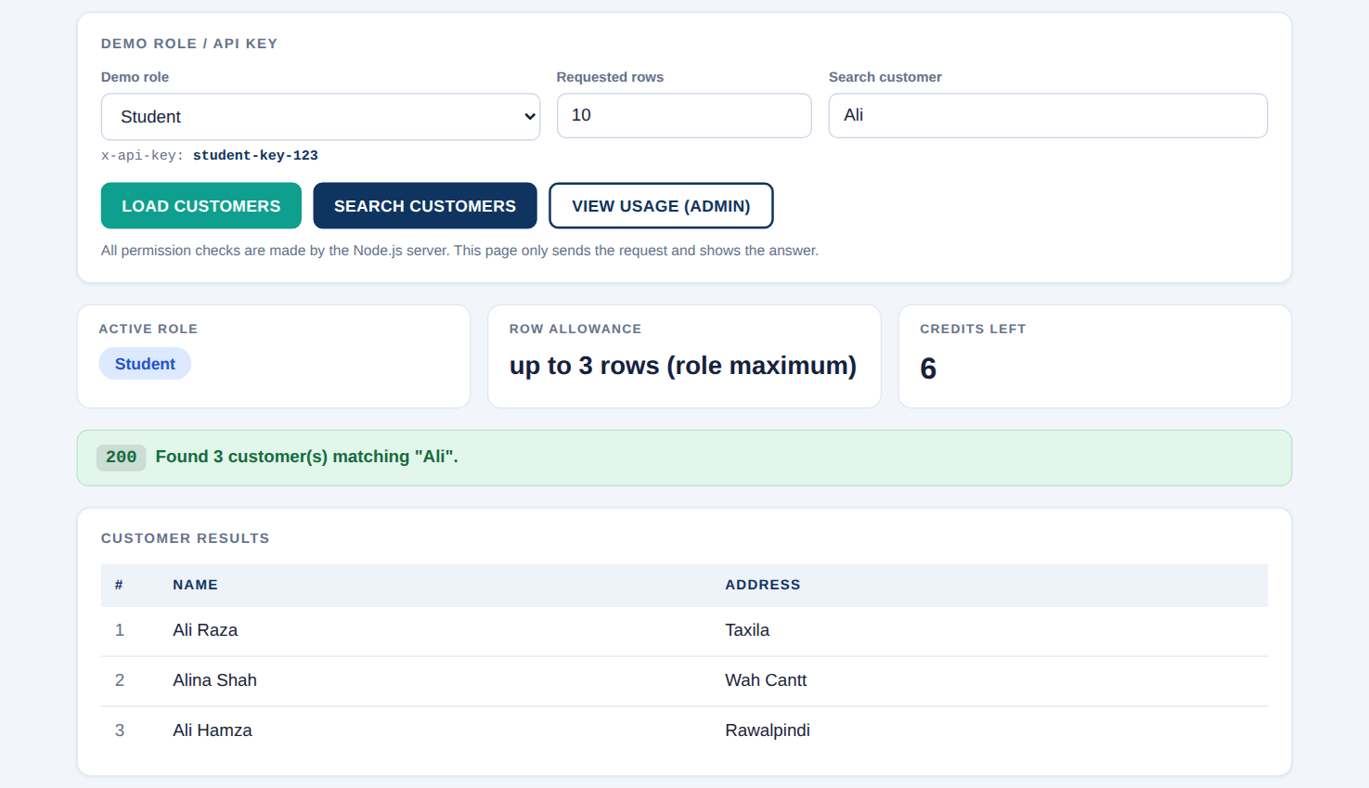
Figure 6: Search Customers as Student

Screenshot 3: 403 Forbidden
A Guest presses Search Customers. The server refuses the action and no credit is used.
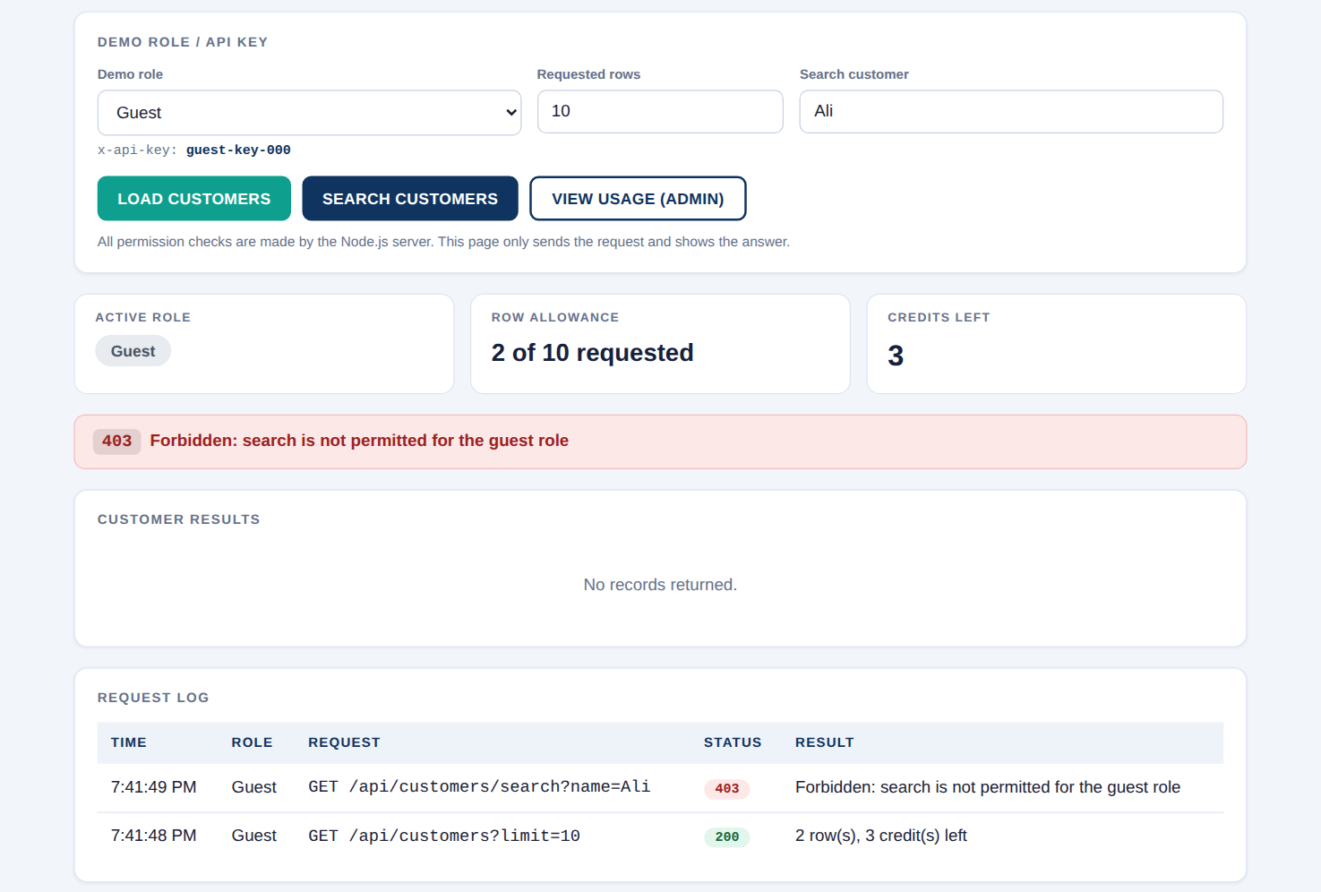
Figure 7: Guest attempts Search: HTTP 403

Screenshot 4: 429 Too Many Requests
The Student has used all 8 credits. The 9th request is rejected and no records are returned.
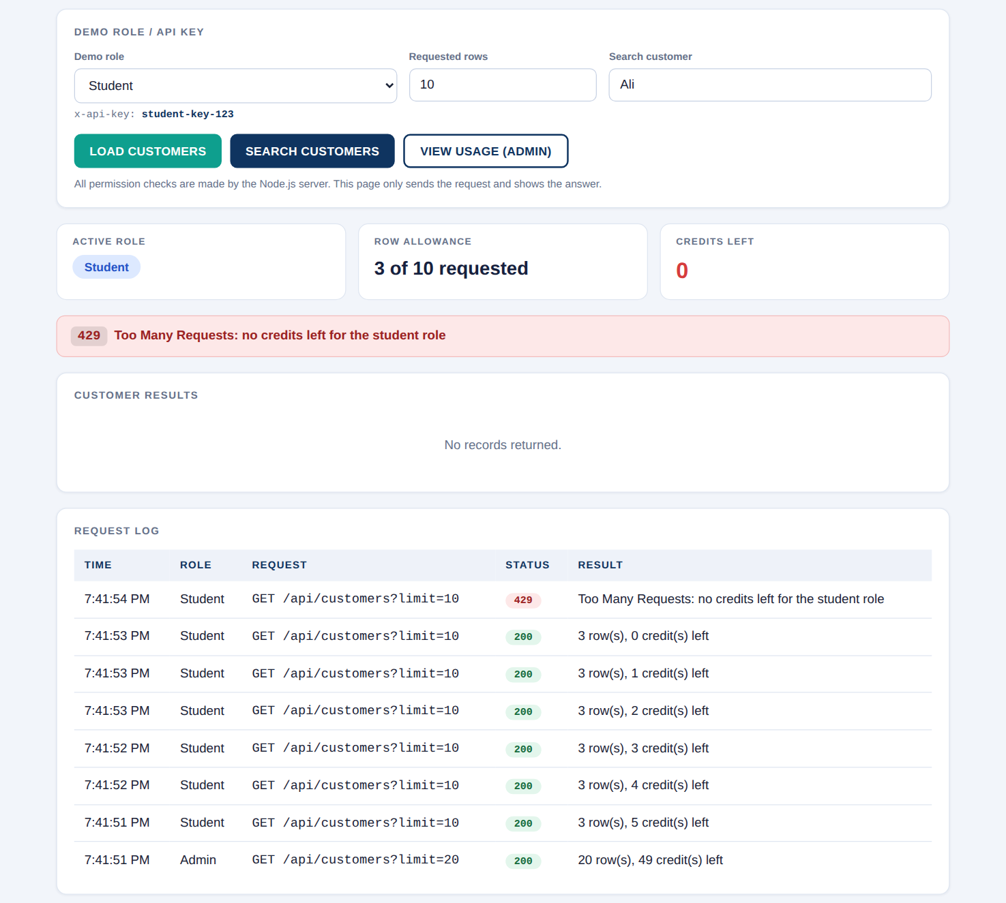
Figure 8: Student 9th request: HTTP 429

Additional Screenshots
Admin usage summary (credits per role, no API keys), unknown key (401) and a non-admin opening the usage endpoint (403).
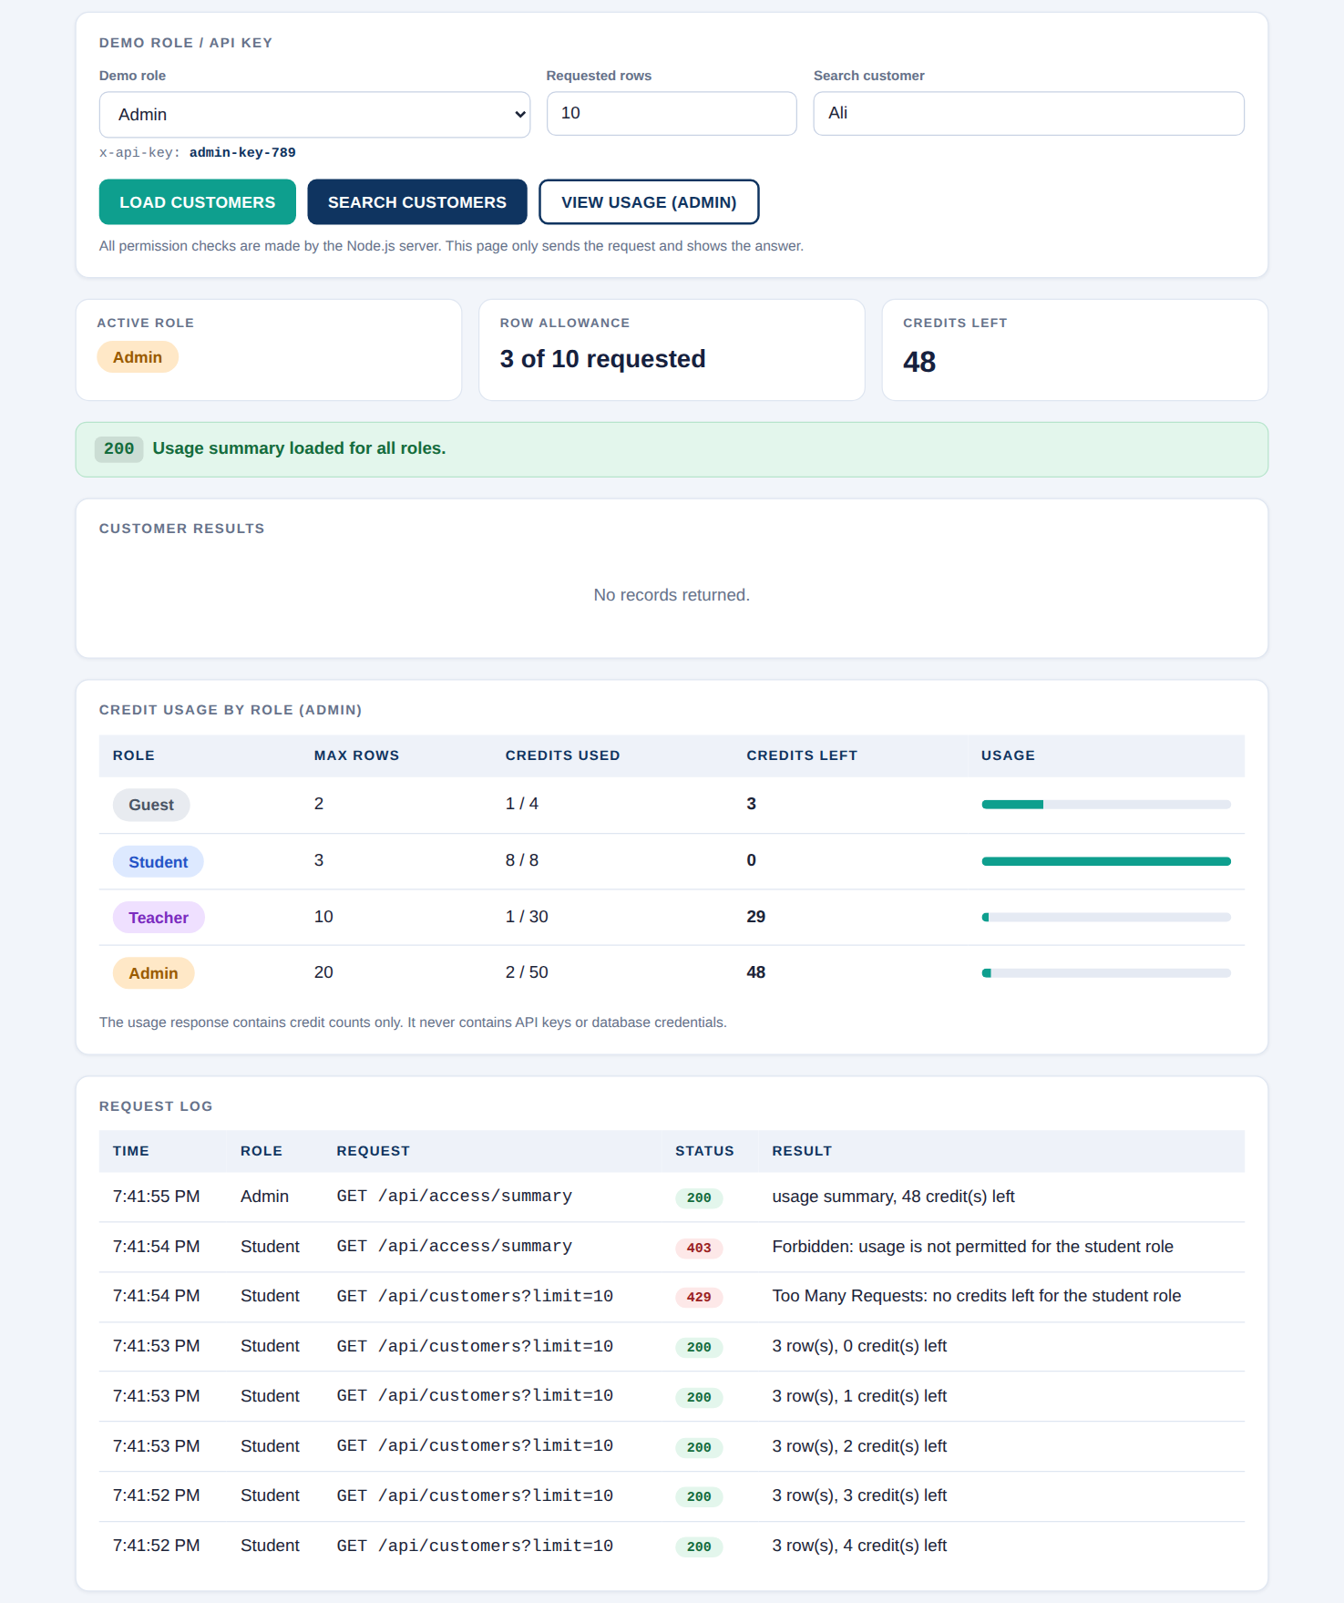
Figure 9: Admin: View Usage
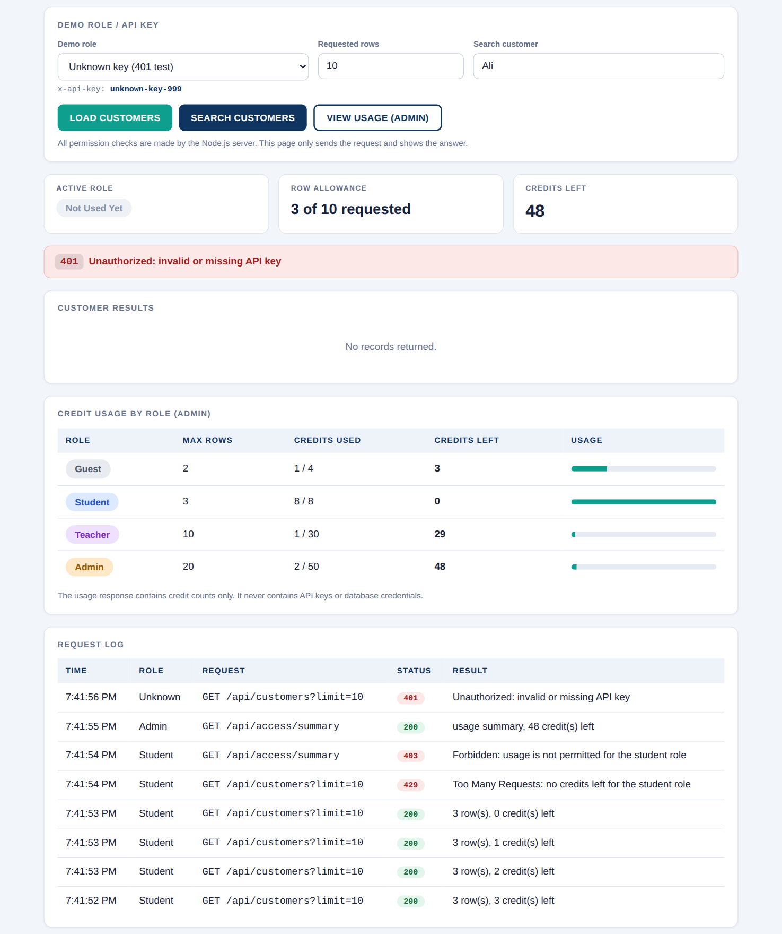
Figure 10: Unknown API key: HTTP 401
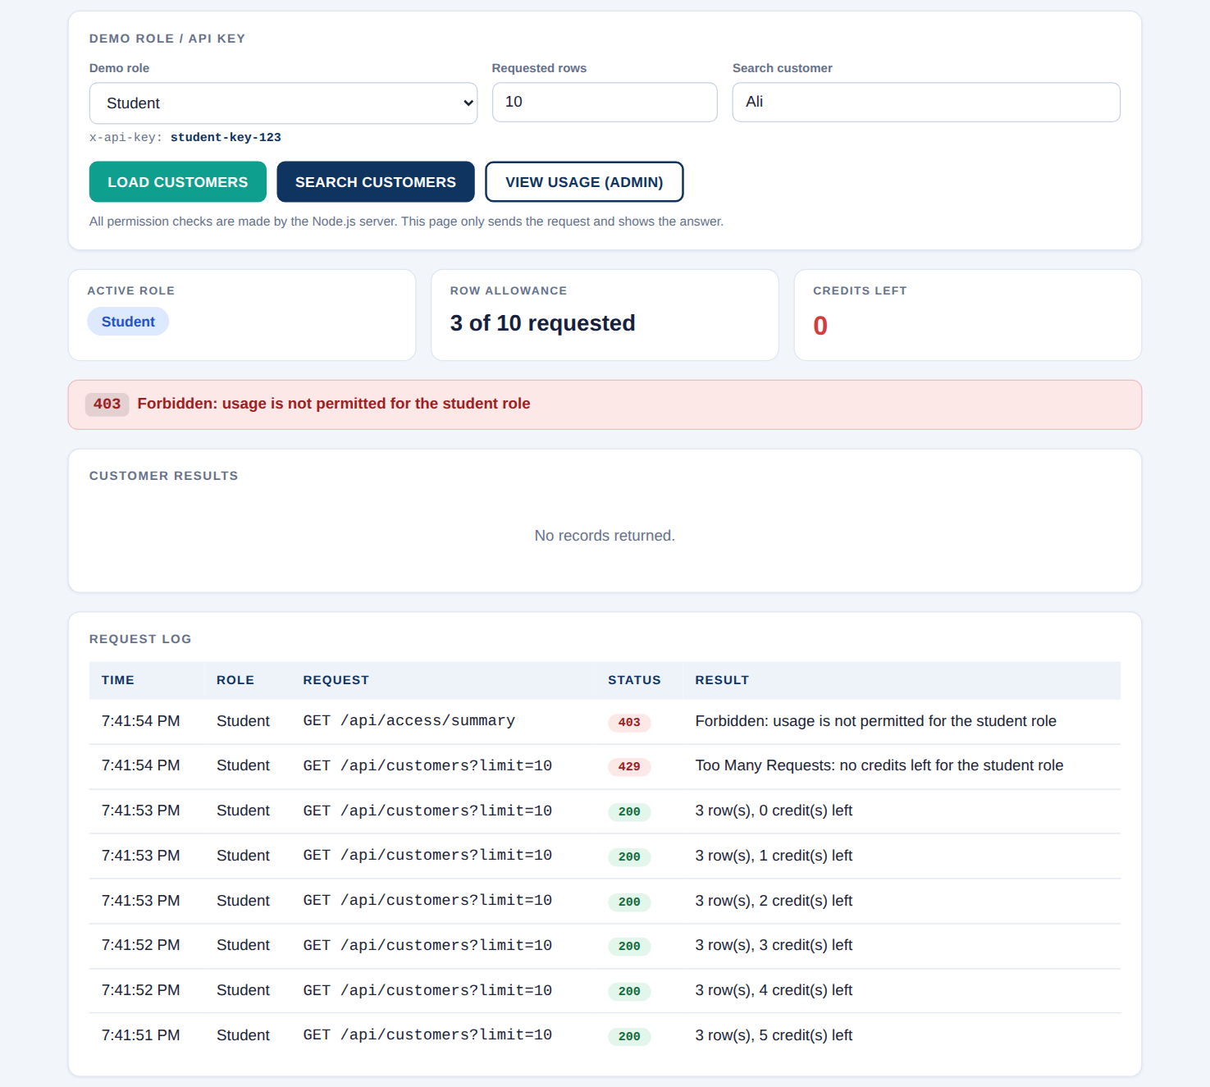
Figure 11: Student opens usage: HTTP 403, even with zero credits left

10. Assessment Checklist
Marking criterion | Marks | Where it is met
Role rules and secure checks | 10 | Four profiles, ordered checks 401/403/429, role-specific SQL columns, bound parameters (Sections 2, 3 and 6)
Load / Search / Usage routes | 8 | Three routes with min(requestedRows, maxRows), role maxRows for search and admin-only usage (Section 5)
Frontend presentation | 6 | Role badges, loading state, empty message, credits, status messages and request log, no page refresh (Section 7)
Testing and submission quality | 6 | All verification cases, four screenshots, README, optional SQL file and this report (Sections 8 and 9)

11. Conclusion
AccessDesk shows that access control must be enforced on the server. The browser only presents the interface; Node.js identifies the caller from the API key, checks the permitted action, database, table and credits, limits the rows, selects only the allowed columns with parameterized SQL, and answers with clear HTTP status codes. Guests cannot search or see addresses, students and teachers have different limits, the admin can inspect credit usage without ever seeing keys, and exhausted credits stop further requests.

